CHAPTER-1

INTRODUCTION PROJECT OVERVIEW:

In the last years, job recommender systems have become popular since they successfully reduce information overload by generating personalized job suggestions. Although in the literature exists a variety of techniques and strategies used as part of job recommender systems, most of them fail to recommending job vacancies that fit properly to the job seekers profiles.

1. Thus, the contributions of this work are threefold, we made publicly available a new dataset formed by a set of job seekers profiles and a set of job vacancies collected from different job search engine sites.
2. Put forward the proposal of a framework for job recommendation based on professional skills of job seekers.
3. carried out an evaluation to quantify empirically the recommendation abilities of two state-of-the-art methods, considering different configurations, within the proposed framework.

We thus present a general panorama of job recommendation task aiming to facilitate research and real-world application design regarding this important issue.

**Keywords**:

Job matching, job seeking, job search, job recommender systems, person-job fit, LinkedIn, word embedding

# PURPOSE:

The recommender system technology aims to help users in finding items that match their personnel interests; it has a successful usage in e-commerce applications to deal with problems related to information overload efficiently.

Recommender systems help the users to get personalized recommendations, helps users to take correct decisions in their online transactions, increase sales and redefine the users web browsing experience, retain the customers, enhance their shopping experience.

Here's where recommendation systems come in handy: they shorten the distance between the customer's need and satisfaction. Not only do they help find the search product; they also discover the needs that customers are not even aware they have.

We are primarily used in commercial applications. Examples of such applications include recommending products on Amazon, music on Spotify, and of course, stories on Medium. The famous The Netflix Prize is also a competition in the context of recommendation systems Recommender systems are techniques that serve the best advice for a potential buyer. They suggest the most relevant items to buy and, as a result, increase a company's revenue. These suggestions are based on users' behaviour and history that contain information on their past preferences.

# CHAPTER-2

**LITERATURE SURVEY REFERENCE**

Adomavicius G, Tuzhilin A (2005). Toward the Next Generation of Recommender Systems: A Survey of the State-of-the-Art and Possible Extensions. IEEE Trans.

Knowl. Data Eng. 17(6):734-749.

Barbieri N, Costa G, Manco G, Ortale R (2011). Modeling Item Selection and Relevance for Accurate Recommendations: A Bayesian Approach. In Proceedings of the fifth ACM conference on Recommender systems (RecSys '11), Chicago, Illinois, USA, ACM pp. 21-28.

Keim T (2007). Extending the Applicability of Recommender Systems:A Multilayer Framework for Matching Human Resources. In Proceedings of the 40th Annual Hawaii International Conference on System Sci. (HICSS'07). Hawaii, USA, IEEE

# PROBLEM STATEMENT

Problem Statement To develop an end-to-end web application capable of displaying the current job openings based on the user skillset. The user and their information are stored in the Database.

An alert is sent when there is an opening based on the user skillset. Users will interact with the chatbot and can get the recommendations based on their skills. We can use a job search API to get the current job openings in the market which will fetch the data directly from the webpage.

We have come up with a new innovation solution through which you can directly choose your job related to your skills without needing help from someone.

User can login into application and search a job otherwise interact with chatbot via entering skills to the bot, it suggests some job based on entered skills and also it updates latest jobs every day, lists of jobs are uploaded into database.

The chatbot also connected with database once user enter skills into chatbot it will search related job in database then it displays various jobs related to skills.

**CHAPTER-3 IDEATION AND PROPOSED SOLUTION EMPATHY MAP CANVAS**

An empathy map is a collaborative tool teams can use to gain a deeper insight into their customers. Much like a user persona, an empathy map can represent a group of users, such as a customer segment.

Objective: To assess the attitudes towards, applicability and usefulness of empathy maps as part of user’s satisfaction in finding a job and connecting them with the industries where they are interested in.

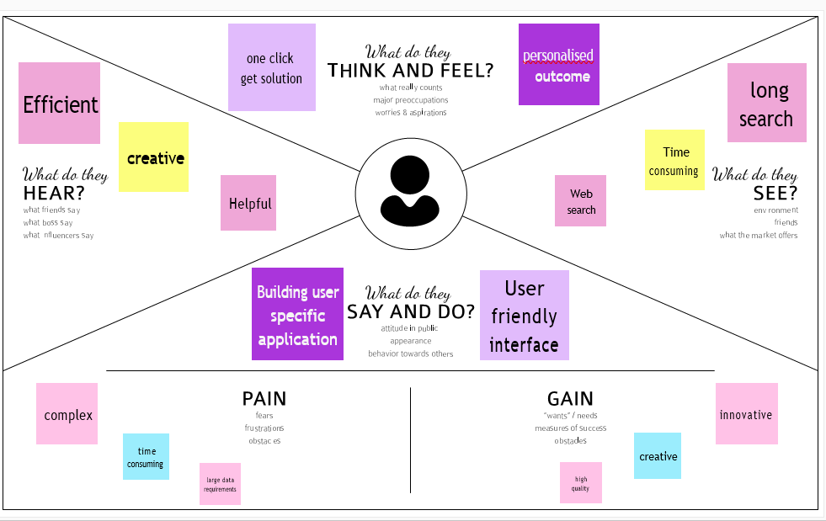

**IDEATION AND BRAINSTROMING**

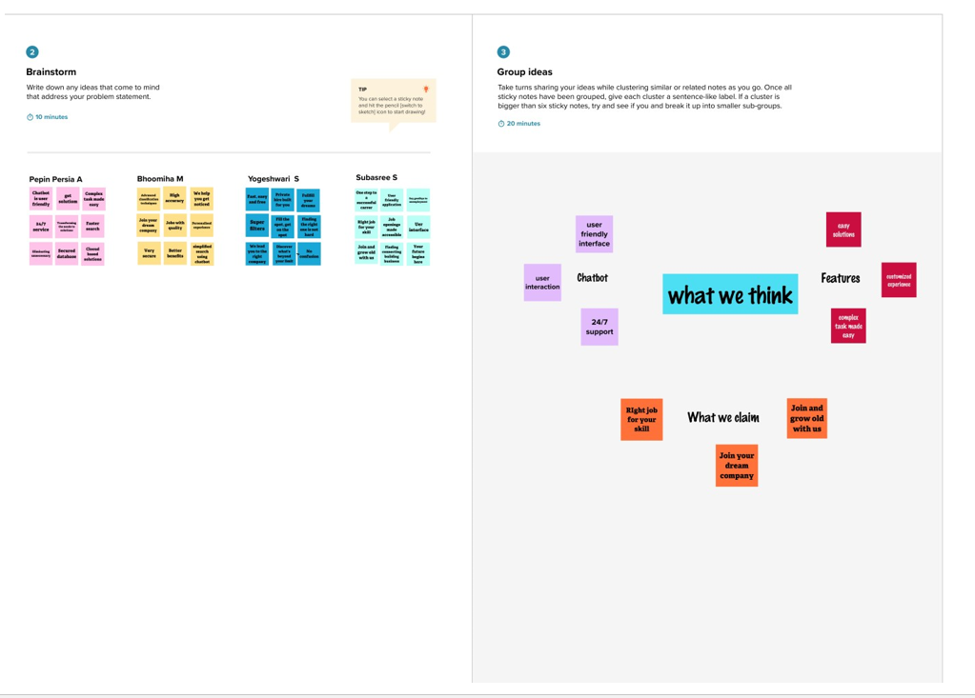

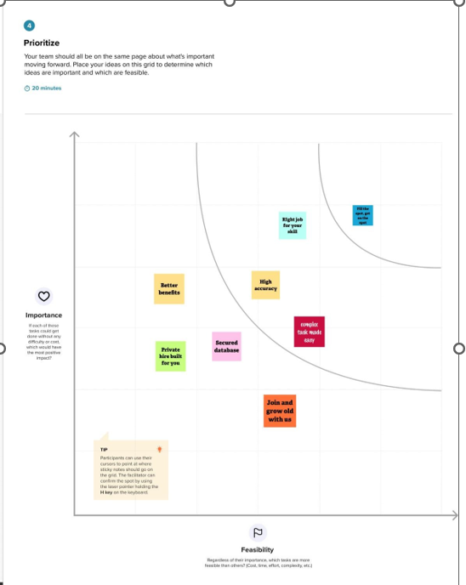

# PROPOSED SOLUTION

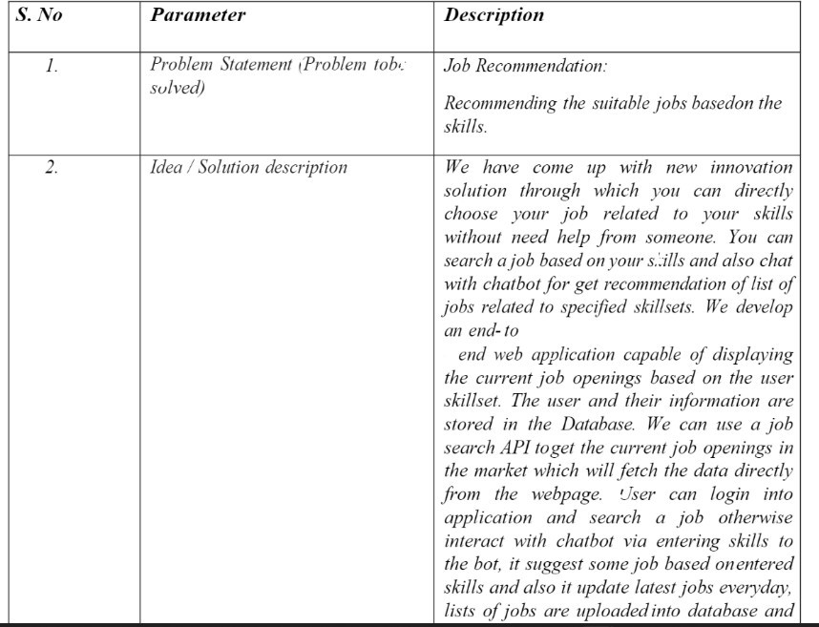

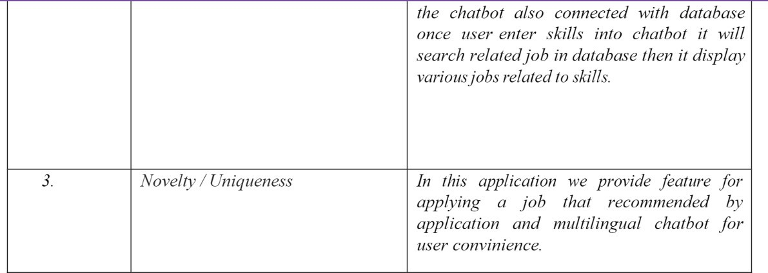

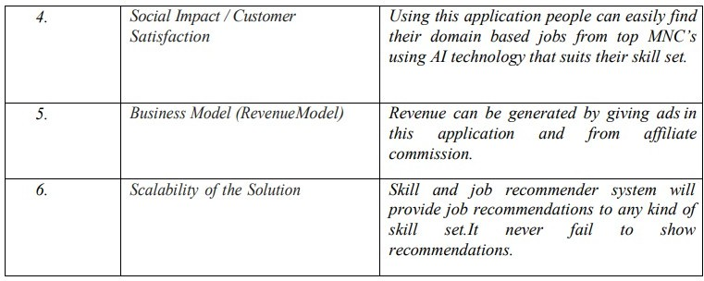

**PROBLEM SOLUTION FIT**

The Problem-Solution Fit simply means that you have found a problem with your customer and that the solution you have realized for it actually solves the customer’s problem.

This system helps the candidates to search an appropriate job by connecting with the industries and increasing their career growth.

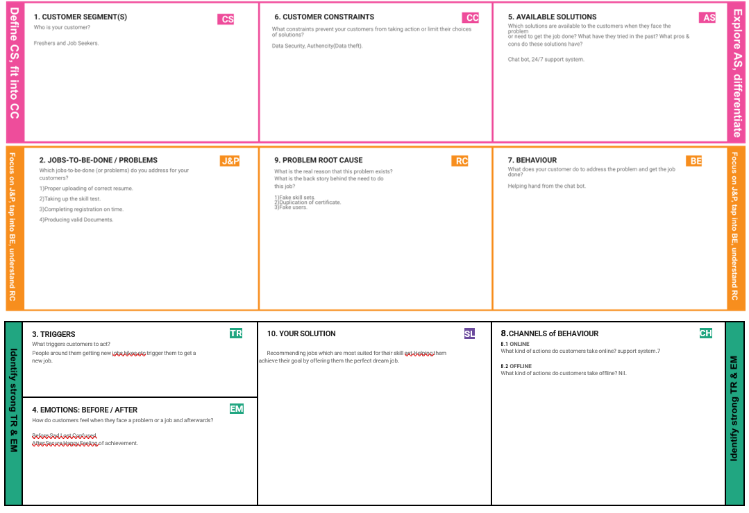

# CHAPTER-4 REQUIREMENT ANALYSIS

Functional Requirements:

Following are the functional requirements of the proposed solution.

|  |  |  |
| --- | --- | --- |
| **FR No.** | **Functional Requirement (Epic)** | **Sub Requirement (Story / Sub-Task)** |
| FR-1 | Sign in / Login | Register with username, password |
| FR-2 | Profile Registration | Register with username, password, email, qualification, skills. This data will be stored in a database. |
| FR-3 | Job profile display | Display job profiles based on availability, location, skills. |
| FR-4 | Chatbot | A chat on the webpage to solve user queries and issues. |
| FR-5 | Job Registration | The company’s registration/Description details will be sent to the registered email id of the user. |
| FR-6 | Logout | Use logout option after completing job registration process. |

|  |  |  |
| --- | --- | --- |
| **FR No.** | **Non-Functional Requirement** | **Description** |
| NFR-1 | **Usability** | The webpage will be designed in such a way that any non-technical user can easily navigate through it and complete the job registration work. (easy and simple design) |
| NFR-2 | **Security** | Using of python flask to cloud connect will provide security to the project. Database will be safely stored in DB2. |
| NFR-3 | **Reliability** | To make sure the webpage doesn’t go down due to network traffic. |
| NFR-4 | **Performance** | Focus on loading the webpage as quickly as possible irrespective of the number of user/integrator traffic. |

Non-functional Requirements:

Following are the non-functional requirements of the proposed solution.

|  |  |  |
| --- | --- | --- |
| NFR-5 | **Availability** | The webpage will be available to all users (network connectivity is necessary) at any given point of time. |
| NFR-6 | **Scalability** | Increasing the storage space of database can increase the number of users. Add some features in future to make the webpage unique and attractive. |

# CHAPTER-5

**PROJECT DESIGN**

# Dataflow Diagrams

A Data Flow Diagram (DFD) is a traditional visual representation of the information flows within a system. A neat and clear DFD can depict the right amount of the system requirement graphically. It shows how data enters and leaves the system, what changes the information, and where data is stored.

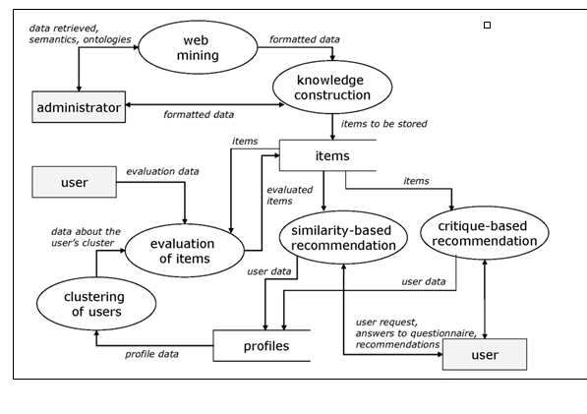

# SOLUTION AND TECHNICAL ARCHITECTURE

The Deliverable shall include the architectural diagram as below and the information as per the table1 & table

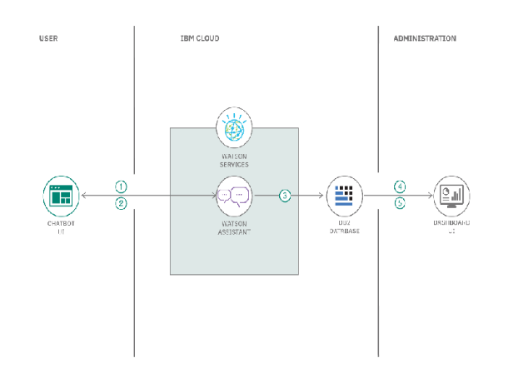

**Table-1: Components & Technologies:**

|  |  |  |  |
| --- | --- | --- | --- |
| **S.No** | **Component** | **Description** | **Technology** |
| 1. | User Interface | The user can interacts with our application with the help of  chatbot, etc. | HTML, CSS, JavaScript / AngularJs / React Js etc. |
| 2. | Application Logic-1 | The User can login with application, by previously he should register in our web app. | Javascript |
| 3. | Application Logic-2 | They can also register with the help of a chatbot. | IBM Watson Assistant |
| 4. | Cloud Database | The user data will be stored and retrieved with the help of this database. | IBM DB2, IBM Cloudant etc. |
| 5. | File Storage | The user documents like photos, resumes and much more will be  stored in cloud bucket, etc., | IBM Block Storage or Other Storage Service or  Local Filesystem |
| 6. | External API | With the help of API, the user can search the job based on their Skillset. | IBM API, etc. |
| 7. | Infrastructure (Server / Cloud) | Application Deployment on Local System / Cloud | Local, Cloud Foundry, Kubernetes, etc. |

**Table-2: Application Characteristics:**

|  |  |  |
| --- | --- | --- |
| **S.No** | **Characteristics** | **Description** |
| 1. | Is it Scalable? | It follows highly scalable technologies that allows application to handle increase in large user data's workload and perform any operation without any problem. |
| 2. | Is it Modifiable? | It is highly Modifiable and Maintenance requires low cost, compared to other applications. |
| 3. | Is the System Robust? | It does not disturb the performance of the computer by not affecting the operating system. It works in minimal hardware systems. |

**CHAPTER-6**

**PROJECT PLANNING & SCHEDULING**

Use the below template to create product backlog and sprint schedule

|  |  |  |  |  |  |  |
| --- | --- | --- | --- | --- | --- | --- |
| **Sprint** | **Functional Requirement (Epic)** | **User Story Number** | **User Story / Task** | **Acceptance criteria** | **Priority** | **Team Members** |
| Sprint-1 | Registration | USN-1 | As a user, I can register for the application by entering my email, password, and  confirming my password. | I can access my account / dashboard | High | Pepin Persia  Subasree.S  Yogeshwari  Bhoomiha |
| Sprint-1 |  | USN-2 | As a user, I will receive confirmation email once I have registered for the application | I can receive confirmation email & click  Confirm | High | Pepin Persia  Subasree.S  Yogeshwari  Bhoomiha |
| Sprint-2 |  | USN-3 | As a user, I can register for the application through Facebook | I can register & access the  dashboard with Facebook Login | Low | Pepin Persia  Subasree.S  Yogeshwari  Bhoomiha |
| Sprint-3 |  | USN-4 | As a user, I can register for the application through Gmail | I can receive confirmation email & click  Confirm | Medium | Pepin Persia  Subasree.S  Yogeshwari  Bhoomiha |
| Sprint-2 | Login | USN-5 | As a user, I can log into the application by entering email & password | I can access my account / dashboard | High | Pepin Persia  Subasree.S  Yogeshwari  Bhoomiha |
| Sprint-2 | Dashboard | USN-6 | Create a model set that | Assign that | High | Pepin Persia  Subasree.S  Yogeshwari  Bhoomiha |
|  |  |  | contains those models, | group to the |  |  |
|  |  |  | then assign it to a role. | appropriate |  |  |
|  |  |  |  | roles on the |  |  |
|  |  |  |  | Roles page |  |  |
| Sprint-4 | Identity-Aware | USN-7 | Open, public | Company | High | Pepin Persia  Subasree.S  Yogeshwari  Bhoomiha |
|  | access, User- authenticated  access, | public website.  App |  |  |
|  |  |  | Employee- | running on |  |  |
|  |  |  | restricted access. | The |  |  |

|  |  |  |  |  |  |  |
| --- | --- | --- | --- | --- | --- | --- |
|  |  |  |  | company intranet. App with access to customer private  information. |  |  |
| Sprint-1 | Communication | USN-8 | A customer care | For how to | Medium | Pepin Persia  Subasree.S  Yogeshwari  Bhoomiha |
|  |  |  | executive is a | tackle customer |  |
|  |  |  | professional responsible | queries. |  |
|  |  |  | for communicating the |  |  |
|  |  |  | how's and why's |  |  |
|  |  |  | regarding service |  |  |
|  |  |  | expectations within a |  |  |
|  |  |  | company. |  |  |
| Sprint-3 | Device  management | USN-9 | You can  Delete/Disable/Enable devices in Azure | Ease of use. | Medium | Pepin Persia  Subasree.S  Yogeshwari  Bhoomiha |
|  |  |  | Active Directory but |  |  |  |
|  |  |  | you cannot |  |  |  |
|  |  |  | Add/Remove Users in the |  |  |  |
|  |  |  | directory. |  |  |  |

**CHAPTER-7**

**CODING &SOLUTIONING FEATURES 1:**

* 1. **Creating an HTML file**
  2. **Converted to a python file using flask. 3.Connecting IBM database using the python file. 4.Creating a Dockerfile**

**FEATURE 2**

**1.Converting the python files to image using Docker Hub. 2.Pushing the images to the container registery.**

**3.With the help of the Kubernetes Node Port number is obtained 4.Web application can be accessed from anywhere.**

**DATASCHEMA**

**1.User Name 2.Email Id 3.Password 4.Qualifications 5.Skills 6.Domain**

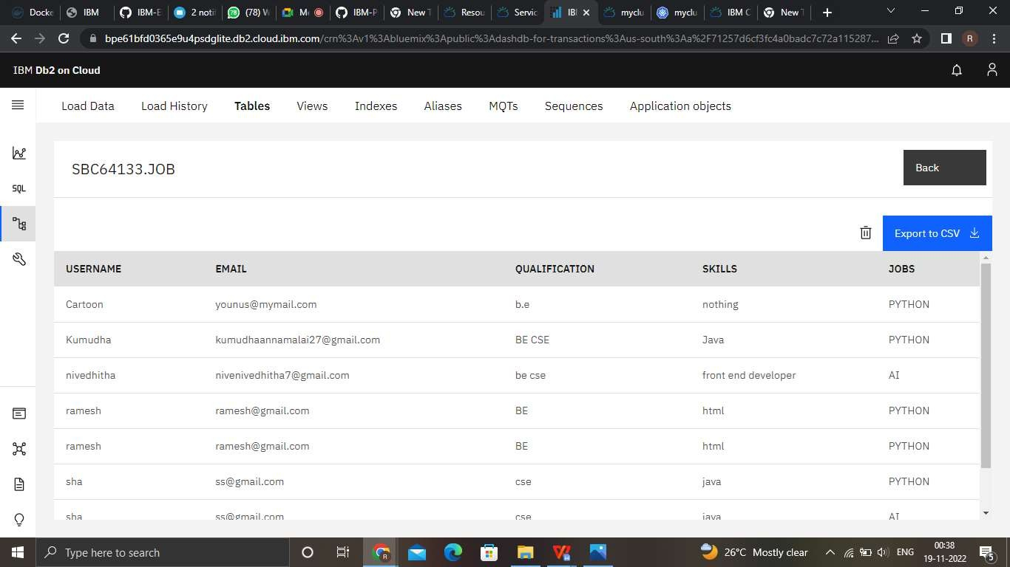

**CHAPTER-8**

**TEST CASES**

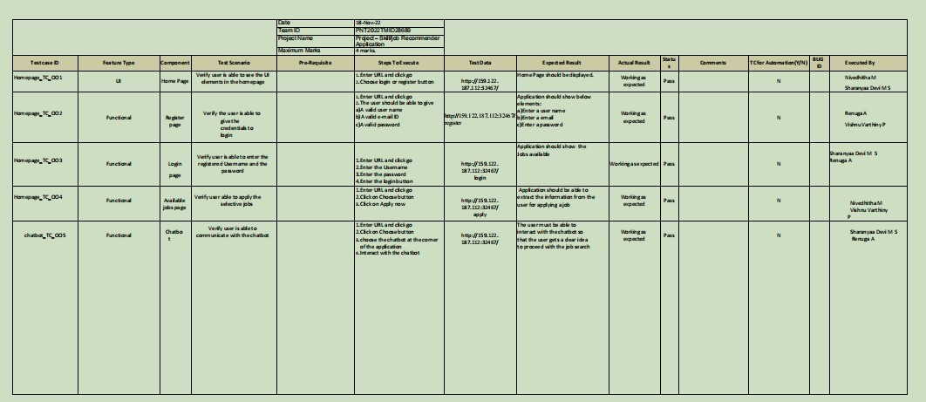

**USER ACCEPTANCE TESTING**

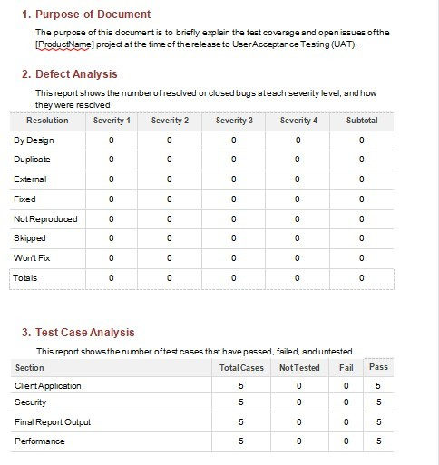

**CHAPTER-9**

**PERFORMANCE METRIC**

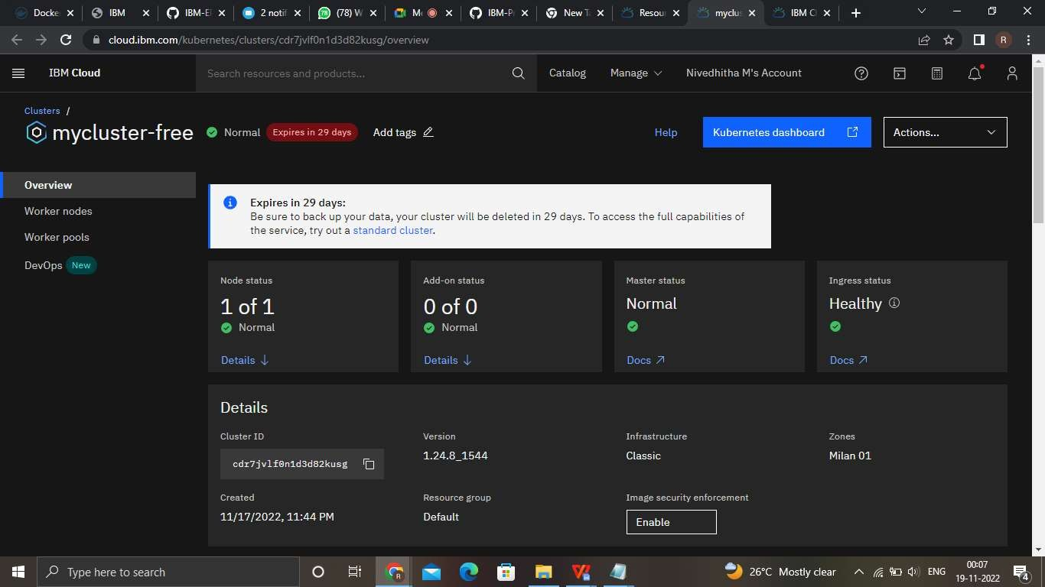

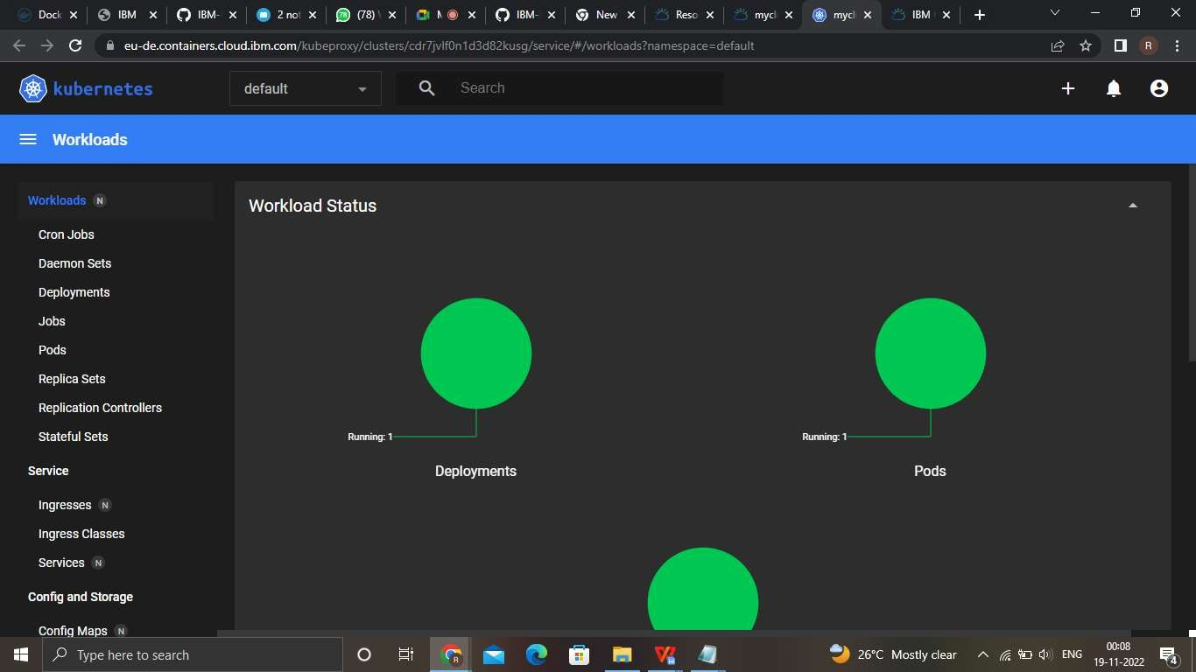

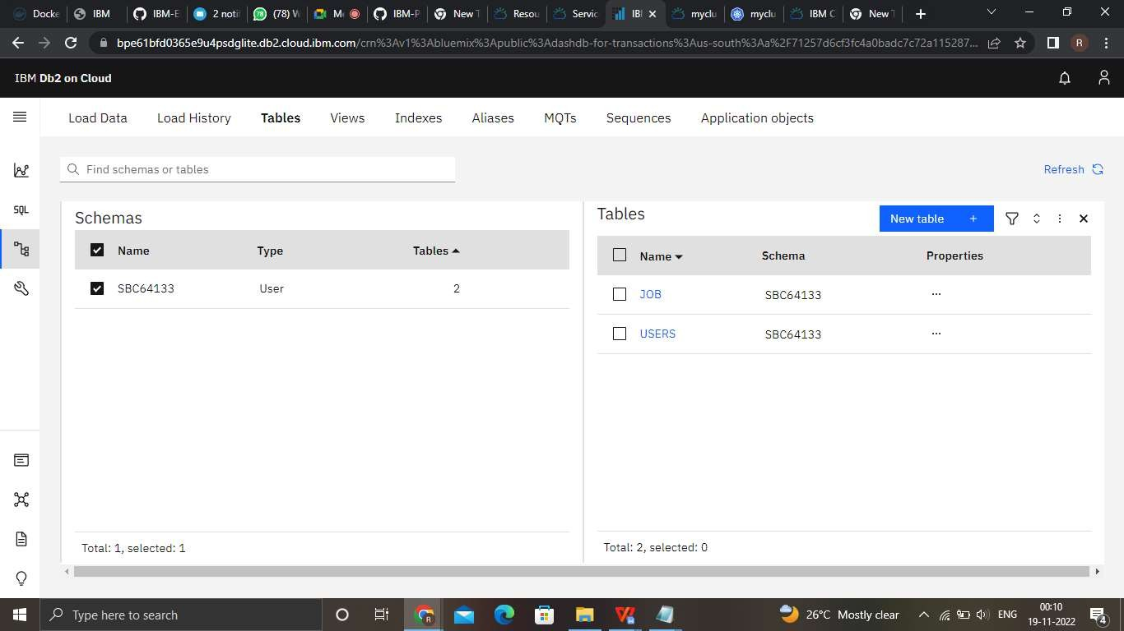

**CHAPTER-10 ADVANTAGES AND DISADVANTAGES**

**Advantages**

It can speak volumes for a candidate-in-question when they are referred by an existing employee. Not only will the current employee, the referrer, likely want to add to—and not detract from company cultures, but they’ll also vouch for required skillsets and competencies.

Help evaluate your employees' competency profile against those required for their jobs and identify gaps for improvement. This data can be used to create personalized development plans that map your employees' paths within the organization.

This encourages a substantial interest in specific research fields and technologies that could benefit the managing of this information overload. The most important fields are Information retrieval and Information filtering. Information retrieval deals with automatically matching user’s information and Information filtering aims to assist users eliminating unwanted information

**Disadvantages**

The biggest disadvantage of Job Analysis process is that it is very time consuming. It is a major limitation especially when jobs change frequently.

If the observer or job analyst is an employee of the same organization, the process may involve his or her personal likes and dislikes. This is a major hindrance in collecting genuine and accurate data.

Because of small sample size, the source of collecting data is extremely small. Therefore, information collected from few individuals needs to be standardized.

The process involves lots of human efforts. As every job carries different information and there is no set pattern, customized information is to be collected for different jobs. The process needs to be conducted separately for collecting and recording job-related data.



**CHAPTER-11**

**CONCLUSION**

The system gives a clear vision of recruiting process and the job recommendation researches. We have seen from our literature review and from the challenges that faced the holistic e-recruiting platforms, an increased need for enhancing the quality of candidates/job matching.

The recommender system technologies accomplished significant success in a broad range of applications and potentially a powerful searching and recommending techniques. Consequently, there is a great opportunity for applying these technologies in recruitment environment to improve the matching quality.

This report shows that several approaches for job recommendation have been proposed, and many techniques combined in order to produce the best fit between jobs and candidates. We presented state of the art of job recommendation as well as, a comparative study for its approaches that proposed by literatures. Additionally, we reviewed typical recommender system techniques and the recruiting process related issues.

We conclude that the field of job recommendations is still unripe and require further improvements. As part of our ongoing research, we aim to build a new recommendation approach and test with real data for employee and staffing data from large companies.

**CHAPTER-12**

**FUTURE SCOPE**

The tremendous growth of both information and usage has led to a so- called information overload problem in which users are finding it increasingly difficult to locate the right information at the right time Thus huge amount of information and easy access to it make recommender systems unavoidable [1]. We use recommender system every day without realizing it and without knowing what exactly happens.

Recommender systems have changed the way people find products, information, and even other people. They study patterns of behaviour to know what someone will prefer from among a collection of things he/she has never experienced. Benefits of recommender systems to the businesses using them include: The ability to offer unique personalized service for the customer, Increase trust and customer loyalty, Increase sales, click-through rates, conversions, etc., Opportunities for promotion, persuasion and Obtain more knowledge about customers.

Recommender systems are software tools and techniques providing suggestions for items to be of use to a user. Job recommender systems are desired to attain a high level of accuracy while making the predictions which are relevant to the customer, as it becomes a very tedious task to explore thousands of jobs, posted on the web.

**APPENDIX**

SOURCECODE HOME PAGE

<!DOCTYPE html>

<html lang="en">

<head>

<title>Bootstrap Example</title>

<meta charset="utf-8">

<meta name="viewport" content="width=device-width, initial-scale=1">

<link rel="stylesheet" href="https://maxcdn.bootstrapcdn.com/bootstrap/3.4.1/css/bootstrap.min.css">

<script src="https://ajax.googleapis.com/ajax/libs/jquery/3.6.0/jquery.min.js"></script>

<script src="https://maxcdn.bootstrapcdn.com/bootstrap/3.4.1/js/bootstrap.min.js"></script>

</head>

<style>

.right{

position: absolute; right: 34px;

top: 10px; display: inline-block;

}

.formwork{ color:blue;

}

.container h5{ font-size: 50px;

color:rgb(0, 0, 0);

font-family: 'Baloo Bhai 2';

}

.btn{

font-family: 'Baloo Bhai 2', cursive; margin: 0px 9px;

background-color: rgb(234, 128, 15); color: white;

text-align:center;

}

.navbar li a{

font-family: 'Baloo Bhai 2', cursive; color: rgb(197, 35, 35);

}

.container u{ color:rgb(18, 231, 142);

}

</style>

<body style="background- image:url('https://images.pexels.com/photos/1242348/pexels-photo- 1242348.jpeg?w=2000');">

<nav class="navbar navbar-inverse">

<div class="container-fluid">

<ul class="nav navbar-nav">

<li class="active"><a href="/">HOME</a></li>

<li><a href="/register">REGISTER</a></li>

<li><a href="/login">LOGIN</a></li>

<li><a href="/about">ABOUT US</a></li>

</ul>

</div>

</nav>

<div class="right">

<form action="/contact" method="get" target="_blank">

<button class="btn">contact us</button>

</form>

</div>

<div class="container">

<center><u><h5>JOB PORTAL<h5></u></center>

</div>

<br>

<!-- bootstrap navbar -->

<nav class="navbar sticky-top navbar-expand-lg navbar-dark">

<div class="container-fluid">

<a class="main-logo-img mt-3" href="#"><img src="" alt="" height="0px" width="0px">

<!-- <a class="navbar-brand" href="index.html">JobPortal</a> -->

</a>

<section class="our-focus">

<div class="container">

<center><h1 class="text-center mt-3">.....ABOUT US </h1></center>

<br>

<br>

alt="..."> -->

<div class="row ml-3 mt-3">

<div class="col-lg-3 mr-5" id="focus-first">

<div class="card" style="width: 19rem;">

<!-- <img src="assets/img/home kids.jpg" class="card-img-top"

<div class="card-body">

<br>

<h5 class="card-title">MISSION</h5>

<b> <p class="card-text">Job recommender is an application that

builds a relation between the candidates and the organisation.

The outcome will be the recommendations based on what domains and the fields that the candidates are intrested.

This system work in areas like search queries,hashtags and more.We have integrated with IBM cloud and used some technologies like python,Docker and more.

</p>

</div>

</div>

</div></b>

<b> <div class="col-lg-3 mr-5" id="focus-second">

<div class="card" style="width: 20rem;">

<!-- <img src="assets/img/friendship day.JPG" class="card-img-

top" alt="..."> -->

<div class="card-body">

<h5 class="card-title">VISSION</h5>

<p class="card-text">Our main objective is to recommend

appropriate jobs for the users and satisfy

their needs by asking them various questions based on the induvidual's interest on domain,salary pakage,area of interest and the skills the are filled with.

With this the young talents will be able to find a job and start a career.It will also support the working employees to develope in their career. </p>

</div>

</div>

</div></b>

<b><div class="col-lg-3 ml-5" id="focus-third">

<div class="card" style="width: 20rem;">

<!-- <img src="assets/img/health camp.jpg" class="card-img-top"

alt="..."> -->

<div class="card-body">

<h5 class="card-title">OBJECTIVE</h5>

<p class="card-text">Well directed career guidance for the employees and the freshers;expand employment accross the world;

identify a perfect candidate for a specific job role;to increase the current industry standards;to make the candidates fly through the employment.</p>

</div>

</div>

</div>

</div>

</div></b>

</section>

<!-- focus section ends -->

<!-- footer starts -->

<!-- Site footer -->

<script> window.watsonAssistantChatOptions = {

integrationID: "db02aed9-1627-4889-b8c4-5cf30e7ab189", // The ID of this integration.

region: "au-syd", // The region your integration is hosted in. serviceInstanceID: "36d66a11-498c-4821-a1a1-6008bddc50e5", // The ID of

your service instance.

onLoad: function(instance) { instance.render(); }

};

setTimeout(function(){

const t=document.createElement('script');

t.src="https://web-chat.global.assistant.watson.appdomain.cloud/versions/" + (window.watsonAssistantChatOptions.clientVersion || 'latest') + "/WatsonAssistantChatEntry.js";

document.head.appendChild(t);

});

</script>

</body>

</html>

REGISTER PAGE

<!DOCTYPE html>

<html lang="en">

<head>

<title>Bootstrap Example</title>

<meta charset="utf-8">

<meta name="viewport" content="width=device-width, initial-scale=1">

<link rel="stylesheet" href="https://maxcdn.bootstrapcdn.com/bootstrap/3.4.1/css/bootstrap.min.css">

<script src="https://ajax.googleapis.com/ajax/libs/jquery/3.6.0/jquery.min.js"></script>

<script src="https://maxcdn.bootstrapcdn.com/bootstrap/3.4.1/js/bootstrap.min.js"></script>

</head>

<style>

.right{

position: absolute; right: 34px;

top: 10px; display: inline-block;

}

.formwork{ color:green;

}

.container h5{ font-size: 50px; color:black;

font-family: 'Baloo Bhai 2';

}

.btn{

font-family: 'Baloo Bhai 2', cursive; margin: 0px 9px;

background-color: rgb(214, 28, 108);

color: rgb(0, 0, 0); text-align:center;

}

.navbar li a{

font-family: 'Baloo Bhai 2', cursive; color: red;

}

.container u{ color:green;

}

</style>

<body style="background-image:url('https://images.pexels.com/photos/1242348/pexels- photo-1242348.jpeg?w=2000');">

<nav class="navbar navbar-inverse">

<div class="container-fluid">

<ul class="nav navbar-nav">

<li class="active"><a href="/">HOME</a></li>

<li><a href="/register">REGISTER</a></li>

<li><a href="/login">LOGIN</a></li>

<li><a href="/about">ABOUT US</a></li>

</ul>

</div>

</nav>

<div class="right">

<form action="/contact" method="get" target="_blank">

<button class="btn">contact us</button>

</form>

</div>

<!-- bootstrap navbar -->

<div class="logo mt-3 text-center">

<a class="main-logo-img mt-5" href="#"><img src="https://thumbs.dreamstime.com/b/round-181587919.jpg" alt="sheep-logo" height="120px" width="300px">

<!-- <a class="navbar-brand" href="index.html">JobPortal</a> -->

</a>

</div>

<!-- navbar ends -->

<!-- Login form -->

<div class="login text-center mt-5">

<h2> REGISTER NOW </h2>

<br>

<form action="/register" method="post">

<div class="msg"></div>

<!-- <input type="text" placeholder="fullname" id="fullname"> </br></br> -->

<input type="text" name="username" placeholder="Enter Your Username" id="username" required></br></br>

<input type="email" name="email" placeholder="Enter Your Email ID" id="email" required></br></br>

<input type="password" name="password" placeholder="Enter Your Password" id="password" required></br></br>

</br>

<button type="submit" id="button" class="btn btn-primary"> Register </button>

</form>

</div>

<br>

<div class="note mt-3 text-center"> <!--Register form -->

<p> already have an account ? please login <a href="/login">login! </a> </p>

</div>

<script> window.watsonAssistantChatOptions = {

integrationID: "db02aed9-1627-4889-b8c4-5cf30e7ab189", // The ID of this integration.

region: "au-syd", // The region your integration is hosted in.

serviceInstanceID: "36d66a11-498c-4821-a1a1-6008bddc50e5", // The ID of your service instance.

onLoad: function(instance) { instance.render(); }

};

setTimeout(function(){

const t=document.createElement('script');

t.src="https://web-chat.global.assistant.watson.appdomain.cloud/versions/" + (window.watsonAssistantChatOptions.clientVersion || 'latest') + "/WatsonAssistantChatEntry.js";

document.head.appendChild(t);

});

</script>

</body>

</html>

LOGIN PAGE

<!DOCTYPE html>

<html lang="en">

<head>

<title>Bootstrap Example</title>

<meta charset="utf-8">

<meta name="viewport" content="width=device-width, initial-scale=1">

<link rel="stylesheet" href="https://maxcdn.bootstrapcdn.com/bootstrap/3.4.1/css/bootstrap.min.css">

<script src="https://ajax.googleapis.com/ajax/libs/jquery/3.6.0/jquery.min.js"></script>

<script src="https://maxcdn.bootstrapcdn.com/bootstrap/3.4.1/js/bootstrap.min.js"></script>

</head>

<style>

.right{

position: absolute; right: 34px;

top: 10px; display: inline-block;

}

.formwork{ color:green;

}

.container h5{ font-size: 50px; color:black;

font-family: 'Baloo Bhai 2';

}

.btn{

font-family: 'Baloo Bhai 2', cursive; margin: 0px 9px;

background-color: blue; color: white;

text-align:center;

}

.navbar li a{

font-family: 'Baloo Bhai 2', cursive; color: red;

}

.container u{ color:green;

}

</style>

<body style="background-image:url('https://images.pexels.com/photos/1242348/pexels- photo-1242348.jpeg?w=2000');">

<nav class="navbar navbar-inverse">

<div class="container-fluid">

<ul class="nav navbar-nav">

<li class="active"><a href="/">HOME</a></li>

<li><a href="/register">REGISTER</a></li>

<li><a href="/login">LOGIN</a></li>

<li><a href="/about">ABOUT US</a></li>

</ul>

</div>

</nav>

<div class="right">

<form action="/contact" method="get" target="_blank">

<button class="btn">contact us</button>

</form>

</div>

<!-- bootstrap navbar -->

<div class="logo mt-3 text-center">

<a class="main-logo-img mt-5" href="#"><img src="https://cengage.force.com/resource/1607465003000/loginIcon" height="150px" width="250px">

<!-- <a class="navbar-brand" href="home.html">JobPortal</a> -->

</a>

</div>

<!-- navbar ends -->

<!-- Login form -->

<div class="login text-center mt-5">

<u><h2> LOGIN FORM </h2></u>

<br>

<form action="/login" method="post">

<div class="msg"><b> WELCOME TO THE LOGIN PAGE </b></div>

<br>

<input type="text" name="username" placeholder="Enter Your Username" id="username" required></br></br>

<input type="password" name="password" placeholder="Enter Your Password" id="password" required></br></br>

</br>

<button type="submit" id="button" class="btn btn-primary"> Login </button>

</form>

</div>

<br>

<div class="note mt-3 text-center"> <!--Register form -->

<p> Don't have an account yet? Click here to <a href="/register">register! </a> </p>

</div>

<script> window.watsonAssistantChatOptions = {

integrationID: "db02aed9-1627-4889-b8c4-5cf30e7ab189", // The ID of this integration.

region: "au-syd", // The region your integration is hosted in.

serviceInstanceID: "36d66a11-498c-4821-a1a1-6008bddc50e5", // The ID of your service instance.

onLoad: function(instance) { instance.render(); }

};

setTimeout(function(){

const t=document.createElement('script');

t.src="https://web-chat.global.assistant.watson.appdomain.cloud/versions/" + (window.watsonAssistantChatOptions.clientVersion || 'latest') + "/WatsonAssistantChatEntry.js";

document.head.appendChild(t);

});

</script>

</body>

</html>

DASHBOARD

<!DOCTYPE html>

<html lang="en">

<head>

<meta charset="UTF-8">

<meta http-equiv="X-UA-Compatible" content="IE=edge">

<meta name="viewport" content="width=device-width, initial-scale=1.0">

<title>JOBPORTAL | HOME</title>

<meta charset="UTF-8">

<!-- favicon -->

<!-- <link rel="shortcut icon" href="/assets/img/favicon.ico" type="image/x- icon"> -->

<!-- <link rel="icon" href="/assets/img/favicon.ico" type="image/x-icon"> -->

<link rel="icon" type="image/png" sizes="16x16" href="/assets/img/favicon- 32x32.png">

<!-- bootstrap css cdn -->

<link rel="stylesheet" href="https://stackpath.bootstrapcdn.com/bootstrap/4.5.2/css/bootstrap.min.css" integrity="sha384- JcKb8q3iqJ61gNV9KGb8thSsNjpSL0n8PARn9HuZOnIxN0hoP+VmmDGMN5t9UJ0Z " crossorigin="anonymous">

<link rel="stylesheet" href="https://cdnjs.cloudflare.com/ajax/libs/font- awesome/4.7.0/css/font-awesome.css">

<!-- css stylesheet -->

<link rel="stylesheet" href="css/style.css">

<!-- font styles cdn -->

<link rel="preconnect" href="https://fonts.gstatic.com">

<link href="https://fonts.googleapis.com/css2?family=Alegreya&display=swap" rel="stylesheet">

<link href="[https://fonts.googleapis.com/css2?family=Alegreya:wght@600&display=swap](https://fonts.googleapis.com/css2?family=Alegreya%3Awght%40600&display=swap)" rel="stylesheet">

</head>

<body style="background-image: url('https://images.pexels.com/photos/684314/pexels- photo-684314.jpeg?auto=compress&amp;cs=tinysrgb&amp;w=2000');">

<!-- bootstrap navbar -->

<nav class="navbar sticky-top navbar-expand-lg navbar-light">

<div class="container-fluid">

<a class="main-logo-img mt-3" href="#"><img src="https://encrypted- tbn0.gstatic.com/images?q=tbn:ANd9GcQJYlncUWMljmSKPkZLKJS5P0VQJhZFwj KbZQ&usqp=CAU" alt="sheep-logo" height="120px" width="300px">

<!-- <a class="navbar-brand" href="index.html">JobPortal</a> -->

</a>

<button class="navbar-toggler" type="button" data-bs-toggle="collapse" data-bs-target="#navbarSupportedContent" aria- controls="navbarSupportedContent" aria-expanded="false" aria-label="Toggle navigation">

<span class="navbar-toggler-icon"></span>

</button>

<div class="row donate-sponsor">

<a type="button" class="btn btn-primary mr-1" id="sponsor" href="/display">DISPLAY</a>

<a type="button" class="btn btn-primary mr-1" id="sponsor" href="/logout">LOG OUT</a>

</div>

</div>

</nav>

<!-- navbar ends -->

<!-- what we focus on -->

<section class="our-focus">

<div class="container">

<h2 class="text-center mt-3">Available Jobs</h2>

<div class="row ml-3 mt-3">

<div class="col-lg-3 mr-5" id="focus-first">

<div class="card" style="width: 19rem;">

<!-- <img src="assets/img/home kids.jpg" class="card-img-top" alt="..."> -

->

<div class="card-body">

<h5 class="card-title">Front End Developer</h5>

<p class="card-text">Skills for Front End Developer

</p>

<a href="apply" class="btn btn-primary">Apply Now</a>

</div>

</div>

</div>

<div class="col-lg-3 mr-5" id="focus-second">

<div class="card" style="width: 20rem;">

<!-- <img src="assets/img/friendship day.JPG" class="card-img-top"

alt="..."> -->

-->

<div class="card-body">

<h5 class="card-title">Data Scientist</h5>

<p class="card-text">Skills for datascientist</p>

<a href="apply" class="btn btn-primary">Apply Now</a>

</div>

</div>

</div>

<div class="col-lg-3 ml-5" id="focus-third">

<div class="card" style="width: 20rem;">

<!-- <img src="assets/img/health camp.jpg" class="card-img-top" alt="...">

<div class="card-body">

<h5 class="card-title">HR Manager</h5>

<p class="card-text">skills for hr manager</p>

<a href="apply" class="btn btn-primary">Apply Now</a>

</div>

</div>

</div>

</div>

</div>

</section>

<!-- focus section ends -->

<!-- footer starts -->

<!-- Site footer -->

<script> window.watsonAssistantChatOptions = {

integrationID: "db02aed9-1627-4889-b8c4-5cf30e7ab189", // The ID of this integration.

region: "au-syd", // The region your integration is hosted in.

serviceInstanceID: "36d66a11-498c-4821-a1a1-6008bddc50e5", // The ID of your service instance.

onLoad: function(instance) { instance.render(); }

};

setTimeout(function(){

const t=document.createElement('script');

t.src="https://web-chat.global.assistant.watson.appdomain.cloud/versions/" + (window.watsonAssistantChatOptions.clientVersion || 'latest') + "/WatsonAssistantChatEntry.js";

document.head.appendChild(t);

});

</script>

</body>

</html>

APPLY PAGE

<!DOCTYPE html>

<html lang="en">

<head>

<meta charset="UTF-8">

<meta http-equiv="X-UA-Compatible" content="IE=edge">

<meta name="viewport" content="width=device-width, initial-scale=1.0">

<title>JOBPORTAL | APPLY</title>

<!-- favicon -->

<!-- <link rel="shortcut icon" href="/assets/img/favicon.ico" type="image/x- icon"> -->

<!-- <link rel="icon" href="/assets/img/favicon.ico" type="image/x-icon"> -->

<link rel="icon" type="image/png" sizes="16x16" href="/assets/img/favicon- 32x32.png">

<!-- bootstrap css cdn -->

<link rel="stylesheet" href="https://stackpath.bootstrapcdn.com/bootstrap/4.5.2/css/bootstrap.min.css" integrity="sha384-

JcKb8q3iqJ61gNV9KGb8thSsNjpSL0n8PARn9HuZOnIxN0hoP+VmmDGMN5t9UJ0Z " crossorigin="anonymous">

<link rel="stylesheet" href="https://cdnjs.cloudflare.com/ajax/libs/font- awesome/4.7.0/css/font-awesome.css">

<!-- css stylesheet -->

<link rel="stylesheet" href="css/style.css">

<!-- font styles cdn -->

<link rel="preconnect" href="https://fonts.gstatic.com">

<link href="https://fonts.googleapis.com/css2?family=Alegreya&display=swap" rel="stylesheet">

<link href="[https://fonts.googleapis.com/css2?family=Alegreya:wght@600&display=swap](https://fonts.googleapis.com/css2?family=Alegreya%3Awght%40600&display=swap)" rel="stylesheet">

</head>

<body style="background-image: url('https://images.pexels.com/photos/1242348/pexels- photo-1242348.jpeg?w=2000');">

<!-- bootstrap navbar -->

<div class="logo mt-3 text-center">

<a class="main-logo-img mt-5" href="#"><img src="https://encrypted- tbn0.gstatic.com/images?q=tbn:ANd9GcTkh2hL43fgGUX0V0cA- 2W7lAIqbm10hE_7yg&usqp=CAU&reload=on" alt="" height="150px" width="400px">

<!-- <a class="navbar-brand" href="home.html">JobPortal</a> -->

</a>

</div>

<!-- navbar ends -->

<!-- Login form -->

<div class="login text-center mt-5">

<h2>Apply Now</h2>

<div class="msg"></div>

<form action="/apply" method="post" class="mt-3">

<!-- <input type="text" placeholder="fullname" id="fullname"> </br></br> -->

<input type="text" name="username" placeholder="Enter Your Username" id="username" required></br></br>

<input type="email" name="email" placeholder="Enter Your email" id="email" required></br></br>

<input type="text" name="qualification" placeholder="Enter Your Qualification" id="qualification" required></br></br>

<input type="text" name="skills" placeholder="Enter Your skills" id="skills" required></br></br>

<select name ="s">

<option value ="PYTHON">front end Developer</option>

<option value ="ML"> ML</option>

<option value ="AI"> AI</option>

</select>

</br></br>

<button type="submit" id="button" class="btn btn-primary"> Submit</button>

</form>

</div>

<div class="note mt-3 text-center">

<p> click here to go to dashboard <a href="/dashboard">Dashboard! </a> </p>

</div>

<script> window.watsonAssistantChatOptions = {

integrationID: "db02aed9-1627-4889-b8c4-5cf30e7ab189", // The ID of this integration.

region: "au-syd", // The region your integration is hosted in.

serviceInstanceID: "36d66a11-498c-4821-a1a1-6008bddc50e5", // The ID of your service instance.

onLoad: function(instance) { instance.render(); }

};

setTimeout(function(){

const t=document.createElement('script');

t.src="https://web-chat.global.assistant.watson.appdomain.cloud/versions/" + (window.watsonAssistantChatOptions.clientVersion || 'latest') + "/WatsonAssistantChatEntry.js";

document.head.appendChild(t);

});

</script>

</body>

</html>

DISPLAY PAGE

<!DOCTYPE html>

<html lang="en">

<head>

<meta charset="UTF-8">

<meta http-equiv="X-UA-Compatible" content="IE=edge">

<meta name="viewport" content="width=device-width, initial-scale=1.0">

<title>JOBPORTAL | HOME</title>

<!-- <div class="msg">{{ msg }}</div> -->

<meta charset="UTF-8">

<!-- favicon -->

<!-- <link rel="shortcut icon" href="/assets/img/favicon.ico" type="image/x- icon"> -->

<!-- <link rel="icon" href="/assets/img/favicon.ico" type="image/x-icon"> -->

<link rel="icon" type="/image/png" sizes="16x16" href="/assets/img/favicon- 32x32.png">

<!-- bootstrap css cdn -->

<link rel="stylesheet" href="https://stackpath.bootstrapcdn.com/bootstrap/4.5.2/css/bootstrap.min.css" integrity="sha384- JcKb8q3iqJ61gNV9KGb8thSsNjpSL0n8PARn9HuZOnIxN0hoP+VmmDGMN5t9UJ0Z " crossorigin="anonymous">

<link rel="stylesheet" href="https://cdnjs.cloudflare.com/ajax/libs/font- awesome/4.7.0/css/font-awesome.css">

<!-- css stylesheet -->

<link rel="stylesheet" href="style.css">

<!-- font styles cdn -->

<link rel="preconnect" href="https://fonts.gstatic.com">

<link href="https://fonts.googleapis.com/css2?family=Alegreya&display=swap" rel="stylesheet">

<link href="[https://fonts.googleapis.com/css2?family=Alegreya:wght@600&display=swap](https://fonts.googleapis.com/css2?family=Alegreya%3Awght%40600&display=swap)" rel="stylesheet">

<style> table, th, td ,tr,thead{ border:5px solid black;

}

</style>

</head>

<body style="background-image:url('https://img.freepik.com/premium- photo/magnifying-glass-blue-background-wallpaper-copy-space-symbol-decoration- ornament-hr-human-recruitment-research-discovery-work-job-career-resume- interview-hiring-employment-choice-focus3d-render_178037-844.jpg?w=1800');">

<!-- bootstrap navbar -->

<nav class="navbar sticky-top navbar-expand-lg navbar-light">

<div class="container-fluid">

<a class="main-logo-img mt-3" href="#"><img src="" alt="">

<!-- <a class="navbar-brand" href="index.html">JobPortal</a> -->

</a>

<button class="navbar-toggler" type="button" data-bs-toggle="collapse" data-bs-target="#navbarSupportedContent" aria- controls="navbarSupportedContent" aria-expanded="false" aria-label="Toggle navigation">

<span class="navbar-toggler-icon"></span>

</button>

<div class="row donate-sponsor">

<a type="button" class="btn btn-success mr-1" id="donate" href="/logout">LOGOUT</a>

<a type="button" class="btn btn-warning mr-1" id="sponsor" href="register">REGISTER</a>

</div>

</div>

</nav>

<!-- navbar ends -->

<!-- what we focus on -->

<div class="m-4 container">

<h1><u>Your Details</u></h1>

</div>

<div class="m-4 container">

<table class="table">

<thead>

<tr>

<th scope="col">Sr.No</th>

<th scope="col">Username</th>

<th scope="col">Emailid</th>

<th scope="col">Qualification</th>

<th scope="col">Skills</th>

<th scope="col">Jobs</th>

</tr>

</thead>

<tbody>

{% for row in account %}

<tr>

<th scope="row">{{loop.index}}</th>

<td>{{row[0]}}</td>

<td>{{row[1]}}</td>

<td>{{row[2]}}</td>

<td>{{row[3]}}</td>

<td>{{row[4]}}</td>

</tr>

{% endfor %}

</tbody>

</table>

</div>

</body>

</html>

CONTACT PAGE

<html lang="en">

<head>

<title>Bootstrap Example</title>

<meta charset="utf-8">

<meta name="viewport" content="width=device-width, initial-scale=1">

<link rel="stylesheet" href="https://maxcdn.bootstrapcdn.com/bootstrap/3.4.1/css/bootstrap.min.css">

<script src="https://ajax.googleapis.com/ajax/libs/jquery/3.6.0/jquery.min.js"></script>

<script src="https://maxcdn.bootstrapcdn.com/bootstrap/3.4.1/js/bootstrap.min.js"></script>

</head>

<style>

.h1{

color:blue;

font-family: 'Baloo Bhai 2';

}

.right{

position: absolute; right: 34px;

top: 10px; display: inline-block;

}

.formwork{ color:green;

}

.container h5{ font-size: 50px; color:black;

font-family: 'Baloo Bhai 2';

}

.btn{

font-family: 'Baloo Bhai 2', cursive; margin: 0px 9px;

background-color: blue; color: white;

text-align:center;

}

.navbar li a{

font-family: 'Baloo Bhai 2', cursive; color: red;

}

.container u{ color:green;

}

</style>

<body style="background-image:url('https://images.pexels.com/photos/1242348/pexels- photo-1242348.jpeg?w=2000');">

<nav class="navbar navbar-inverse">

<div class="container-fluid">

<ul class="nav navbar-nav">

<li class="active"><a href="/">HOME</a></li>

<li><a href="/register">REGISTER</a></li>

<li><a href="/login">LOGIN</a></li>

<li><a href="/about">ABOUT US</a></li>

</ul>

</div>

</nav>

<footer class="site-footer">

<b><div class="container mt-5">

<div class="row">

<div class="col-sm-12 col-md-6">

<h3>JOB PORTAL</h3>

<p class="text-justify">Contact us to simplify your job search with the our job recommender system.

Connect with the world's widespread industries and on a professional

system.

Build a bridge with others from your industry on a good professional

network. Apply for jobs, upskill in your area. Find & Apply To New Jobs

and enjoy your career with highest upscales and development with our Skills/job recommender system. Find the job you need and easily apply for the jobs you want.</p>

</div>

<div class="col-xs-6 col-md-3">

<h4>Get in Touch</h4>

<ul class="footer-links">

<li><a href="<mailto:test@gmail.com>">[jobportal@gmail.com](mailto:jobportal@gmail.com)</a></li>

<li><a href="">+91 900000000</a></li>

</ul>

</div>

</div>

<hr>

</div>

**</div></b>**

</footer>

<script> window.watsonAssistantChatOptions = {

integrationID: "db02aed9-1627-4889-b8c4-5cf30e7ab189", // The ID of this integration.

region: "au-syd", // The region your integration is hosted in.

serviceInstanceID: "36d66a11-498c-4821-a1a1-6008bddc50e5", // The ID of your service instance.

onLoad: function(instance) { instance.render(); }

};

setTimeout(function(){

const t=document.createElement('script');

t.src="https://web-chat.global.assistant.watson.appdomain.cloud/versions/" + (window.watsonAssistantChatOptions.clientVersion || 'latest') + "/WatsonAssistantChatEntry.js";

document.head.appendChild(t);

});

</script>

</body>

</html>

ABOUT PAGE

<html lang="en">

<head>

<title>Bootstrap Example</title>

<meta charset="utf-8">

<meta name="viewport" content="width=device-width, initial-scale=1">

<link rel="stylesheet" href="https://maxcdn.bootstrapcdn.com/bootstrap/3.4.1/css/bootstrap.min.css">

<script src="https://ajax.googleapis.com/ajax/libs/jquery/3.6.0/jquery.min.js"></script>

<script src="https://maxcdn.bootstrapcdn.com/bootstrap/3.4.1/js/bootstrap.min.js"></script>

</head>

<style>

.text-center mt-3 h1{ color:blue;

font-family: 'Baloo Bhai 2';

}

.h1{

color:blue;

font-family: 'Baloo Bhai 2';

}

.right{

position: absolute; right: 34px;

top: 10px; display: inline-block;

}

.formwork{ color:green;

}

.container h5{ font-size: 50px; color:black;

font-family: 'Baloo Bhai 2';

}

.btn{

font-family: 'Baloo Bhai 2', cursive; margin: 0px 9px;

background-color: blue; color: white;

text-align:center;

}

.navbar li a{

font-family: 'Baloo Bhai 2', cursive; color: red;

}

.container u{ color:green;

}

</style>

<body style="background- image:url('https://images.pexels.com/photos/1242348/pexels-photo- 1242348.jpeg?w=2000');">

<nav class="navbar navbar-inverse">

<div class="container-fluid">

<ul class="nav navbar-nav">

<li class="active"><a href="/">HOME</a></li>

<li><a href="/register">REGISTER</a></li>

<li><a href="/login">LOGIN</a></li>

<li><a href="/about">ABOUT US</a></li>

</ul>

</div>

</nav>

<div>

<br>

<br>

alt="..."> -->

<br>

<center><h1 class="text-center mt-3">ABOUT US</h1></center>

</div>

<center><div class="row ml-3 mt-3">

<b> <div class="col-lg-3 mr-3" id="focus-first">

<div class="card" style="width: 19rem;">

<!-- <img src="assets/img/home kids.jpg" class="card-img-top"

<div class="card-body">

<u><h5 class="card-title">MISSION</h5></u>

<p class="card-text">Job recommender is an application that

builds a relation between the candidates and the organisation.

The outcome will be the recommendations based on what domains and the fields that the candidates are intrested.

This system work in areas like search queries,hashtags and more.We have integrated with IBM cloud and used some technologies like python,Docker and more..

</p>

</div>

</div>

</div></b>

<b><div class="col-lg-4 mr-4" id="focus-second">

<div class="card" style="width: 20rem;">

<!-- <img src="assets/img/friendship day.JPG" class="card-img-

top" alt="..."> -->

<div class="card-body">

<u><h5 class="card-title">VISSION</h5></u>

<p class="card-text">Our main objective is to recommend

appropriate jobs for the users and satisfy

their needs by asking them various questions based on the induvidual's interest on domain,salary pakage,area of interest and the skills the are filled with.

With this the young talents will be able to find a job and start a career.It will also support the working employees to develope in their career. </p>

</div>

</div>

</div></b>

alt="..."> -->

<b><div class="col-lg-4 ml-4" id="focus-third">

<div class="card" style="width:20rem;">

<!-- <img src="assets/img/health camp.jpg" class="card-img-top"

<div class="card-body">

<u><h5 class="card-title">OBJECTIVE</h5></u>

<p class="card-text">Well directed career guidance for the

employees and the freshers;expand employment accross the world;

identify a perfect candidate for a specific job role;to increase the current industry standards;to make the candidates fly through the employment.

</p>

</div>

</div>

</div>

</div>

</div></b>

</section>

</center>

<br>

<br>

<br>

<br>

<br>

<br>

<!-- focus section ends -->

<!-- footer starts -->

<!-- Site footer -->

<hr>

</div>

</div>

</footer>

<script> window.watsonAssistantChatOptions = {

integrationID: "db02aed9-1627-4889-b8c4-5cf30e7ab189", // The ID of this integration.

region: "au-syd", // The region your integration is hosted in. serviceInstanceID: "36d66a11-498c-4821-a1a1-6008bddc50e5", // The ID of

your service instance.

onLoad: function(instance) { instance.render(); }

};

setTimeout(function(){

const t=document.createElement('script');

t.src="https://web-chat.global.assistant.watson.appdomain.cloud/versions/" + (window.watsonAssistantChatOptions.clientVersion || 'latest') + "/WatsonAssistantChatEntry.js";

document.head.appendChild(t);

});

</script>

</body>

</html>

GITHUB LINK

https://github.com/IBM-EPBL/IBM-Project-50271-1660901567